Fursuit Prices
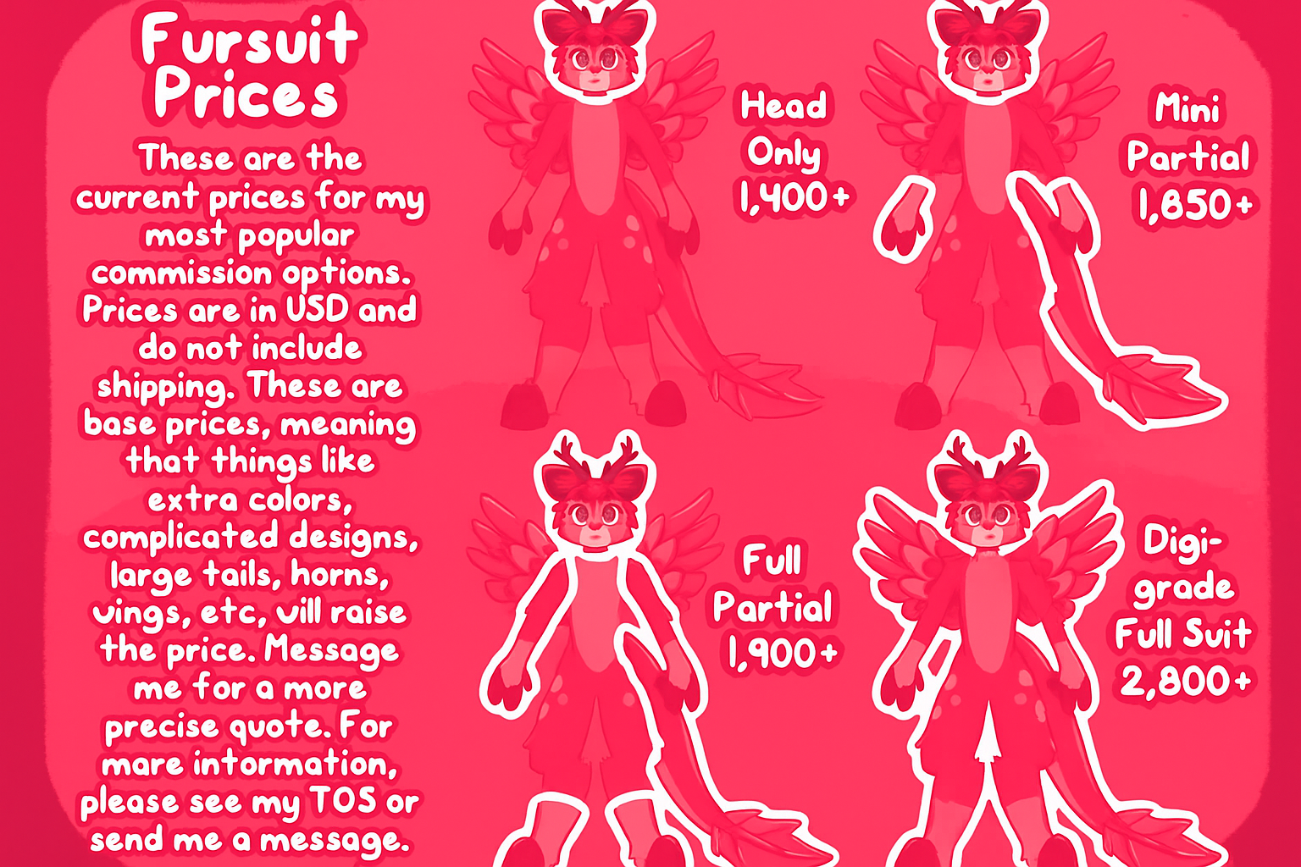
These Are the prices for my most popular commision options. Prices are in USD anddo not include shipping. These are base prices, meaning that things like extra colors, complicated designs, large tails, horns, vings, rc. will raise the precise quote. For more informaion, please see my TOS or send me a messeage as well as contact our website.

