Art Commissions
Terms of Service
-I have the rights to refuse a commission
-Payment via PayPal, payment upfront
-Sketch will be sent for approval
-No refunds or changes can be done after lineart
-I’m not responsible for what happens to the artwork after it’s shipped (traditional artwork)
-Can take around 1-4 weeks, you can ask me anytime for updates
-An extra character cost 50% of original price
-Do not use my art in AI generators
I will draw
-Animals/ furries (Anthro and feral)
-Humans
-Gore
-Ponies
-Pets
-Fandoms I'm familiar with
I will not draw
-NSFW
-Fetish artwork
-Fandoms I’m not familiar with (ask)
-Anything offensive/ controversial
Digital chibi | Traditional badges | Flatcolored | Shaded | Digital scene
Headshot $25 | Headshot $35 | Headshot $24 | Headshot $40 | Headshot +$50
Halfbody $35 | Halfbody $45 | Halfbody $33 | Halfbody $52 | Halfbody +$100
Fullbody $50 | Fullbody $65 | Fullbody $45 | Fullbody $69 | Fullbody +$150
Reference sheet
$30 Includes 1 full body + 1 headshot
Extra little chibi +$9
Extra headshot +$15
Extra fullbody +$30
Custom charcter
$99
Will need a description and/or moodboard

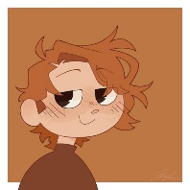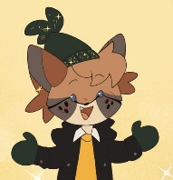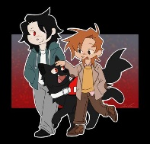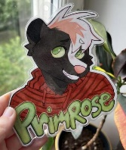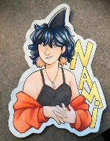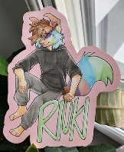
Chibi example Badge examples
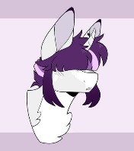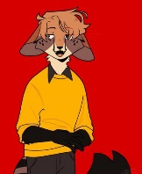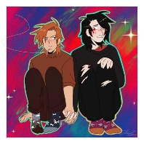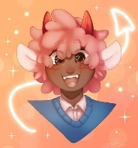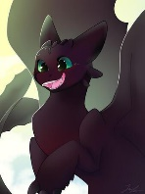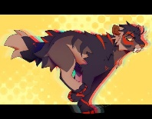
Flatcolored examples Scene examples
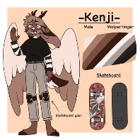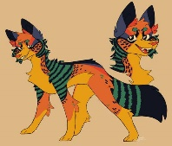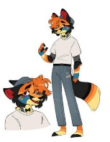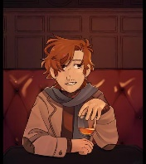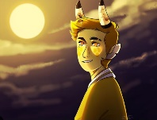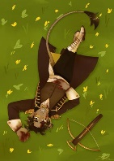
Custom Design examples References sheet examples

